**BOOKS BY VISITING AUTHOR, WENDY MASS**

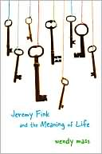

**JEREMY FINK AND THE MEANING OF LIFE**

Twelve-year-old Jeremy receives a wooden box in the mail with the words, “The Meaning of Life—for Jeremy Fink to open on his 13th birthday.” The box has four locks, requiring four keys. But the keys are missing. He and his best friend Lizzy (who has a little habit of stealing things) set off on a quest through the streets of Manhattan to find the keys before time runs out.

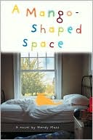**A Mango-Shaped Space**

[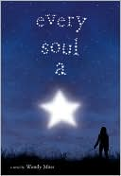](http://search.barnesandnoble.com/Every-Soul-a-Star/Wendy-Mass/e/9780316002561/?itm=1)Thirteen-year-old Mia Winchell appears to be the most normal kid in her family. Her younger brother Zack keeps a chart of all the McDonald's hamburgers he's eaten in his lifetime. Her older sister Beth dyes her hair a different color every week and might be a witch. But Mia knows she is far from ordinary. She is keeping something from everyone who knows her: the fact that sounds, numbers, and letters have color for her.

**Every Soul a Star**

ALLY likes the simple things in life--labyrinths, stargazing, and comet hunting. Her home, the Moon Shadow Campground, is a part of who she is. BREE is popular, gorgeous (everybody says so), and a future homecoming queen for sure. She wears her beauty like a suit of armor. But what is she trying to hide? JACK, overweight and awkward, is used to spending a lot of time alone. But when opportunity knocks, he finds himself in situations he never would have imagined. When the three of them meet during a total eclipse of the sun, their lives change forever.



**11 BIRTHDAYS**

Amanda's 11th birthday should have been a happy occasion. Instead she's dressed in an itchy costume her mother picked out for her Hollywood-themed party that almost no one comes to. Meanwhile, across town, her ex-best friend Leo is celebrating their joint birthday with a huge bash including a hypnotist, a football star, a giant iguana, and a rock band. Amanda can't wait for the day AFTER her birthday so she can stop thinking about the fight that led to her and Leo having separate parties for the first time in their lives. There's just one problem. The next day is her birthday all over again. Amanda must figure out how to get un-stuck, in more ways than one.



**FINALLY**

Book 2 in the Willow Falls series. Rory Swenson has been waiting her whole life to turn twelve. And she’s got a list to prove it. But as she makes her way through the list, things don’t go quite as planned! Fun, funny, and full of surprises, this is a story about wanting to finally grow up, even when the universe seems to be telling you to wait.

**13 GIFTS**

Book 3 in the Willow Falls series. When Tara tries to steal the school mascot in order to make friends with the popular crowd and gets caught, she gets sent to spend the summer with her aunt, uncle, and strange cousin Emily St. Claire in Willow Falls. Things start off weird and only get stranger from there as she has to find mysterious objects hidden around town and unravels secrets about her own family she never would have guessed.

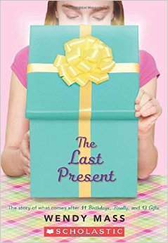

**THE LAST PRESENT**

Book 4 in the Willow Falls series. Amanda and Leo have a history with birthdays. Now their friend's little sister, Grace, has fallen into a strange frozen state on her birthday, and Amanda and Leo must travel back in time in order to heal her As they journey back to each of Grace's birthdays, they uncover a lot more than they ever expected, and set a powerful force into motion.

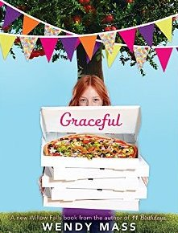

**GRACEFUL**

Last book in the Willow Falls series! Angelina D'Angelo has left town to see the world. It's now Grace's turn to use her magic to protect the people of Willow Falls, and she is up to the challenge. This is her destiny, after all. But destiny is a funny thing because it doesn't always behave the way you'd expect it to.

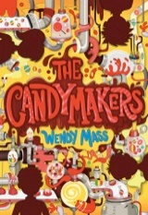**THE CANDYMAKERS**

Four children have been chosen to compete in a national competition to create the best new candy. Who will invent a candy more delicious than the Oozing Crunchorama or the Neon Yellow Lightning Chew? Logan, the Candymaker's son, who can detect the color of chocolate by touch alone? Miles, the boy who is allergic to merry-go-rounds and the color pink? Daisy, the cheerful girl who can lift a fifty-pound lump of taffy like it's a feather? Or Philip, the suit-and-tie wearing boy who's always scribbling in a secret notebook? This story, told from each contestant's perspective, is candy-coated mystery full of mouthwatering surprises!

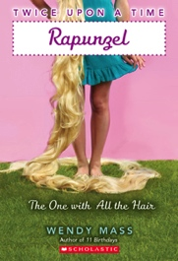

**TWICE UPON A TIME: RAPUNZEL**

Journey back to the days when fairy tales were true, and remember, there are two sides to every story...Rapunzel is having the ultimate bad day. She's been stolen by a witch, may have a ghost for a roommate, and doesn't even have a decent brush for her hair. Prince Benjamin’s got it pretty tough, too. His father wants him to be more kingly, his mother wants him to never leave her sight, and his cousin wants to get him into as much trouble as possible (preferably with a troll). Both Rapunzel and Prince Benjamin are trapped...in very different ways. Once their paths cross, well, that’s when things REALLY get strange.

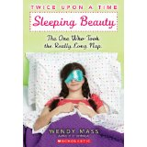

**SLEEPING BEAUTY: THE ONE WHO TOOK A REALLY LONG NAP (TWICE UPON A TIME)**

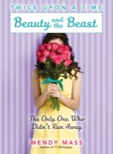It's not easy being Princess Rose. Especially when a fairy curses you and you find yourself avoiding all sharp objects . . . and then end up pricking your finger anyway, causing you to slumber for a hundred years or so. And it's not easy being The Prince. Especially when your mother has some ogre blood and tends to chow down at the most unfortunate moments. A walk in the woods would help, you think. Until you find a certain hidden castle . . . and a certain sleeping princess. Happily ever after? Not until the prince helps the princess awaken . . . and brings her home to mother.

**BEAUTY AND THE BEAST: THE ONE WHO DIDN’T RUN AWAY (TWICE UPON A TIME)**

When Beauty’s life turns completely upside down and she is forced to head out into the world, she has to figure out just who she wants to be. And when Prince Riley suddenly grows fur, and nails as sharp as sticks, he has to learn that appearances can be deceiving. Before Beauty and Riley can save each other, they have to save themselves.

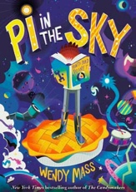

**PI IN THE SKY**

Joss comes from a family of overachievers, and is happy to let his older brothers shine. But when Earth suddenly disappears, Joss is tasked with the not-so-simple job of bringing it back. With the help of an outspoken girl named Annika, Joss embarks on the adventure of a lifetime and learns that the universe is an even stranger place than he'd imagined.

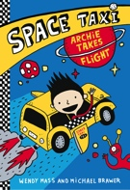

**SPACE TAXI: ARCHIE TAKES FLIGHT**

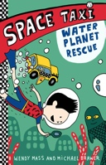The first book in a series for early readers! 8-year-old Archie Morningstar learns that his dad isn’t a regular taxi driver. He’s actually a SPACE taxi driver! His job is to shuttle aliens from planet to planet. Archie discovers he has the ability to read the space map that guides his dad’s taxi through space. He can’t imagine anything more exciting—until he meets a very special talking cat and helps save the universe!

**SPACE TAXI 2: WATER PLANET RESCUE**

In the second book in this series, Archie, his dad, and Pockets fly to a planet in peril: someone is stealing the water from this underwater world! Can Archie and Pockets save the day?

**SPACE TAXI 3: ARCHIE’S ALIEN DISGUISE**

Archie, his dad, and Pockets visit a planet that resembles medieval Earth in every way but its inhabitants, who have rainbow colored hair and extra eyes. To beat the evil organization B.U.R.P., the trio must disguise themselves as aliens and rescue a princess!

**The two YOUNG ADULT titles below are intended for Seventh Grade readers and up:**

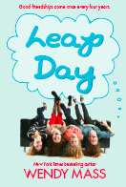 **LEAP DAY** Sixteen-year-old Josie Taylor was born on Leap Day, February 29, and today is her “fourth” birthday! Today it's the reader who gets to find out what it’s like being born on Leap Day, by "leaping" into the minds and viewpoints of Josie and everyone around her, changing your assumptions of people forever.

**HEAVEN LOOKS A LOT LIKE THE MALL:** 16-year-old Tessa is a spunky heroine who hasn't always made the right choices. By reliving her life according to the purchases she’s made at the mall, she just might discover what makes life worth living.

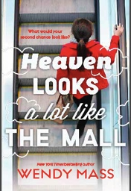

|  |  |  |  |  |  |  |  |  |
| --- | --- | --- | --- | --- | --- | --- | --- | --- |
| **Title of Book** | **Price** | **Quantity** | **Title of Book** | **Price** | **Quantity** | **Title of Book** | **Price** | **Quantity** |
| Jeremy Fink | 8.00 |  | Last Present | 7.00 |  | Pi in the Sky | 8.00 |  |
| Mango Shaped Space | 8.00 |  | Graceful (hardcover) | 17.00 |  | Archie Takes Flight | 6.00 |  |
| Every Soul A Star | 9.00 |  | Candymakers | 9.00 |  | Water Planet Rescue | 6.00 |  |
| 11 Birthdays | 7.00 |  | Rapunzel | 7.00 |  | Leap Day | 9.00 |  |
| Finally | 7.00 |  | Sleeping Beauty | 7.00 |  | Heaven…Mall | 9.00 |  |
| 13 Gifts | 7.00 |  | Beauty and the Beast | 7.00 |  | Archie’s Alien Disguise | 6.00 |  |

Full Name______________________________________________ Homeroom Teacher ____________________

Please pay cash or make a check made out to

AUTOGRAPH BOOKS TO (first name) :____________________________________

(Please note if you’d like a specific book to be signed to someone else, if giving as a gift)

**PLEASE RETURN TO Ms. Yost BY May 13.**

**THANK YOU and HAPPY READING!**